Memorandum
To: Various
From: Jan Ozer
Date: April 24, 2018
Re: Per-Title Encoding Session at Streaming Media East
Overview:
I’m running a per-title encoding bake-off at Streaming Media East. The format will be similar to that shown in the attached presentation. Here’s the high level description:
- Fifteen 1080p files ranging from screencam to high motion movie content (see Appendix I)
- Each contestant will output two encoding ladders; one a “baseline” ladder with seven fixed rungs at specified parameters, the other an optimized per-title ladder. All comparisons will be between the two file groups prepared by the same vendor; there will be no cross vendor file comparisons.
- The grading will be similar to that shown in the attached presentation that uses a baseball metaphor (wins, losses, saves, etc.). Some definitions may change slightly but the fundamental comparison method will not.
- The attached spreadsheet shows how the results are scored, and includes the results for capped CRF and a random third-party vendor. There are two tabs for each test subject, one for recording the results (_results), the other for the analysis (_analysis). The analysis tab computes the improvement in experience that a viewer would have at each particular data rate due to the per-title technology.
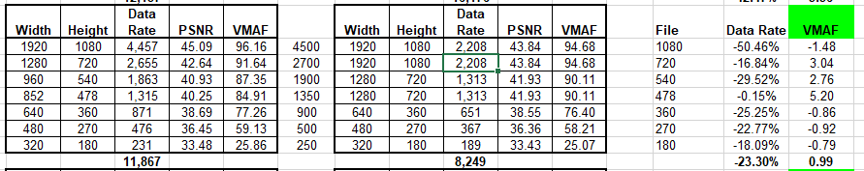
This is shown in the table above. On the left is the baseline content, on the right the per title. Using the standard ladder (on the left) a viewer with a bandwidth of 1350 kbps would watch an 852x478 resolution file. However, since the per-title technology produced a 720p file at 1,313 kbps, a viewer watching the optimized ladder at the same bandwidth would watch the 720p file. On the right, we see that this delivers an improvement in VMAF rating of 5.20.
This analysis, which relies upon VMAF, is fundamental to the overall scoring schema. If it doesn’t make sense to you, or you don’t think it fairly evaluates your technology, you shouldn’t participate.

Encoding:
Here’s the encoding ladder for the baseline encodes.
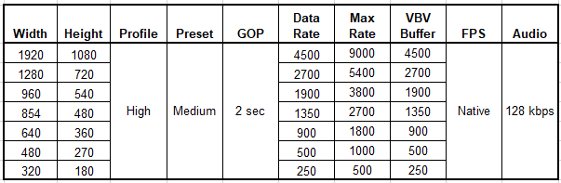
The per-title encode must use the same profile, preset, and GOP size, and 200% CVBR if possible. The data rate of the per-title files can be up to 150% of the target. The per-title encode can change the data rate, resolution, and number of files in the encoding ladder.

Operation:
The per-title encoding technique must be generic and can’t be customized for a particular test file. All contestants must provide access to their technology so that I can run the tests. You can assist in setting the parameters, but they must be identical for all encoded files.

Access to Test Files:
Contestants can download the source files and the comparison files prepared using Capped CRF for their own analysis. I will be changing the Capped CRF from 150% constrained VBR to 200%, and the profile to High. Capped CRF performed pretty well last time out, so if your technology can’t do better than Capped CRF, you probably shouldn’t participate.

Time Table:
I’m targeting May 2 as the date to have all files complete. I need to know if you intend to participate by Friday, April 27.
Please let me know if you have any questions; I know there’s a lot here.

Appendix I
File List
Title | Genre
Elektra (2 minutes) | Movie
El Ultimo (1 minutes) | Simple animated movie
Epiphan screencam (4:22) | Mixed screencam and real world video
Freedom (4:25) | Music video
Haunted (2 minutes) | Movie like video
Ironman preview (1:52) | Animated movie
New (92 seconds) | Test clip
Screencam (2 minutes) | Screencam only
Sintel (2 minutes) | Animated movie
Spongebob preview (2:17) | Animated movie
Tears of Steel (2 minutes) | Movie with computer generated content
Test (8 minutes) | Mixed talking head and ballet
Talking Head (2 minutes) | Simple talking head
Tutorial (2 minutes) | Mixed PowerPoint and small video
Zoolander (5 minutes) | Movie footage

